



Assignment Title: Developing an AI-Driven Model for Heart Disease Prediction
Program title: Introduction to Artificial Intelligence
Name: Gaurav Arun
Year: 2025
Student ID: Q1096266

CONTENTS

- INTRODUCTION

- CHAPTER ONE - DATA PREPROCESSING

- CHAPTER TWO – MODEL SELECTION AND TRAINING

- CHAPTER THREE – MODEL EVALUATION AND PERFORMANCE ANALYSIS

- CHAPTER FOUR – AIRTIFICIAL INTELLIGENCE IN HEALTHCARE

- CONCLUSION

- BIBLIOGRAPHY

Statement of compliance with academic ethics and the avoidance of plagiarism

I honestly declare that this dissertation is entirely my own work and none of its part has been copied from printed or electronic sources, translated from foreign sources and reproduced from essays of other researchers or students. Wherever I have been based on ideas or other people texts I clearly declare it through the good use of references following academic ethics.
(In the case that is proved that part of the essay does not constitute an original work, but a copy of an already published essay or from another source, the student will be expelled permanently from the program).

Name and Surname (Capital letters):
GAURAV ARUN
.......................................................................................................................................

Date: 02/04/2025

INTRODUCTION

Early diagnosis of cardiovascular diseases (CVDs) stands as an essential requirement since these diseases currently represent major global mortality contributors. The current diagnostic techniques depend on physician-based evaluation combined with manual assessments yet they sometimes result in late findings and mistakes in diagnosis. Large data analysis through Artificial Intelligence (AI) and Machine Learning (ML) systems combined with predictive automated models establishes an effective solution to detect heart disease at early stages by revealing hidden patterns beyond human detection capabilities.

The goal of this assignment is to create an Artificial Intelligence-based model through machine learning approaches for forecasting heart disease incidences. Predictive analysis takes place using five different classifiers which consist of Logistic Regression alongside Decision Tree and Random Forest methods plus Gradient Boosting and Support Vector Machine (SVM). The preprocessing steps enable us to scale features while managing outliers before evaluating models through accuracy rates and precision, recall, F1-score assessments together with AUC-ROC calculations.

The paper explores the wider scope of AI in healthcare through an examination of diagnostic precision boost and practice efficiency improvement as well as accessibility improvement alongside a study of data protection and moral dilemmas. The research aims to identify the best machine learning algorithm for heart disease prediction alongside investigating the ability of artificial intelligence to transform medical diagnostic procedures.

CHAPTER ONE: DATA PREPROCESSING

To achieve reliable machine learning modeling it required data preprocessing as an essential first step. The preprocessing process creates datasets that contain clear and consistent data which is appropriate for model development tasks.
- Handling Missing Data -
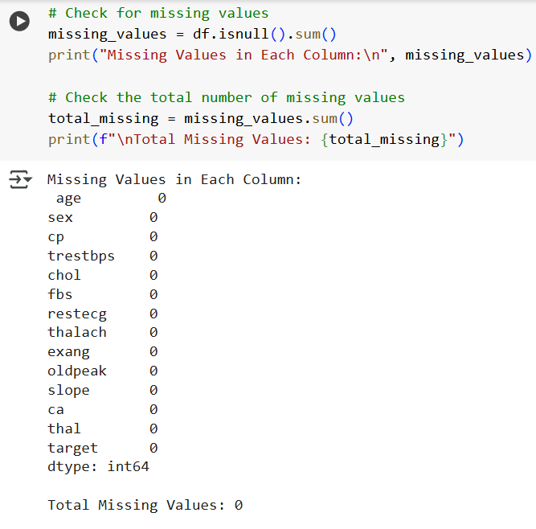
- The performance of a model becomes compromised when missing values exist within its data points. An analysis of missing values started before proceeding with the dataset.

- Feature Scaling -
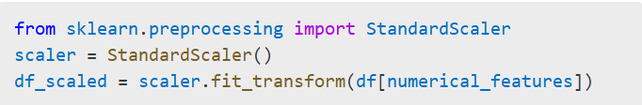
- Maximal model performance emerges from numerical features that have similar value ranges. Standardication procedures were performed with StandardScaler found with the sklearn.preprocessing library.
- Target Variable Distribution Analysis –
- When preparing data the distribution pattern of the target variable stands as an essential foundation step. The dataset contains a target variable named target which indicates heart disease diagnosis through one (1) for patients with heart disease and zero(0) for those without.
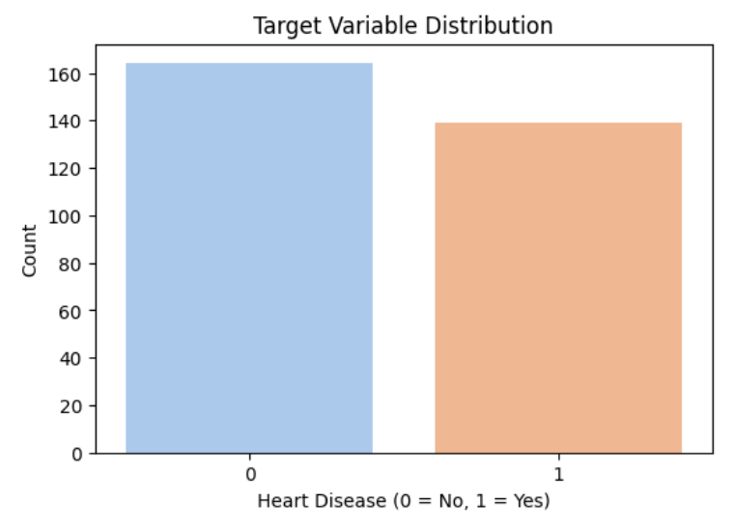
- The target variavle distribution appears as a count plot when created through sns.countplot(). The visualization shows whether the dataset contains an imbalance at a glance. The prediction accuracy requires balancing when sample distribution presents an imbalance and techniques like oversampling and undersampling and class-weighted modeling could help achieve this ojective.
- Numerical Feature Analysis-
- Before applying a machine learning model for traning investigators must first analyze the numerical feature distributions. Data structure along with detection of patterns and outliers becomes possible through this process which aids model performance assessment.
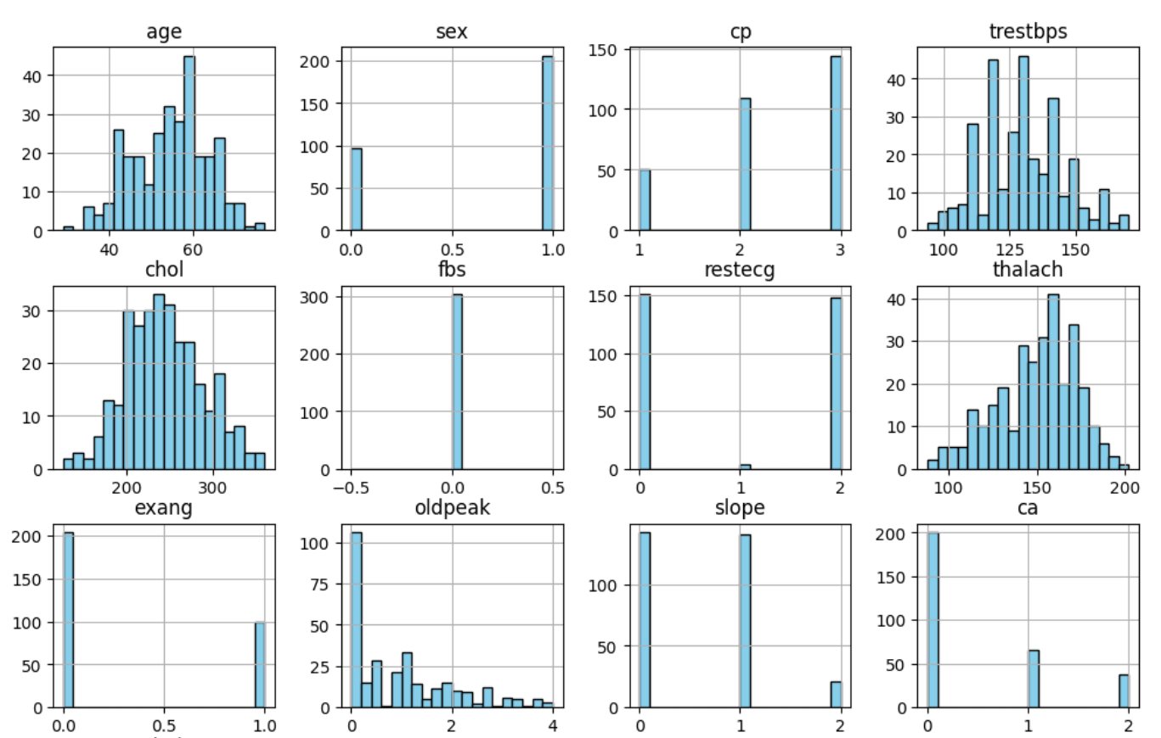
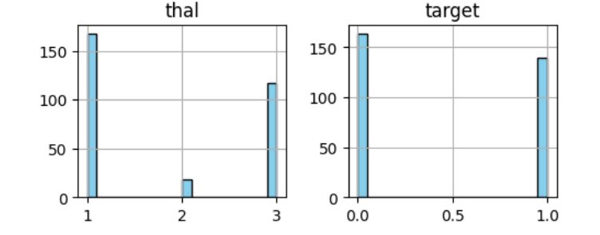

- Outlier Detection and Handling –
- Machine learning models face significant impact when outliers skew distributions because they influence on model performance. The Interquartile Range (IQR) approach identifies and deals with outlier numerical data points in features.
- Any value which exists outside the specified lower and upper limits gets classified as an outlier before being substituted by the median value of that particular feature.
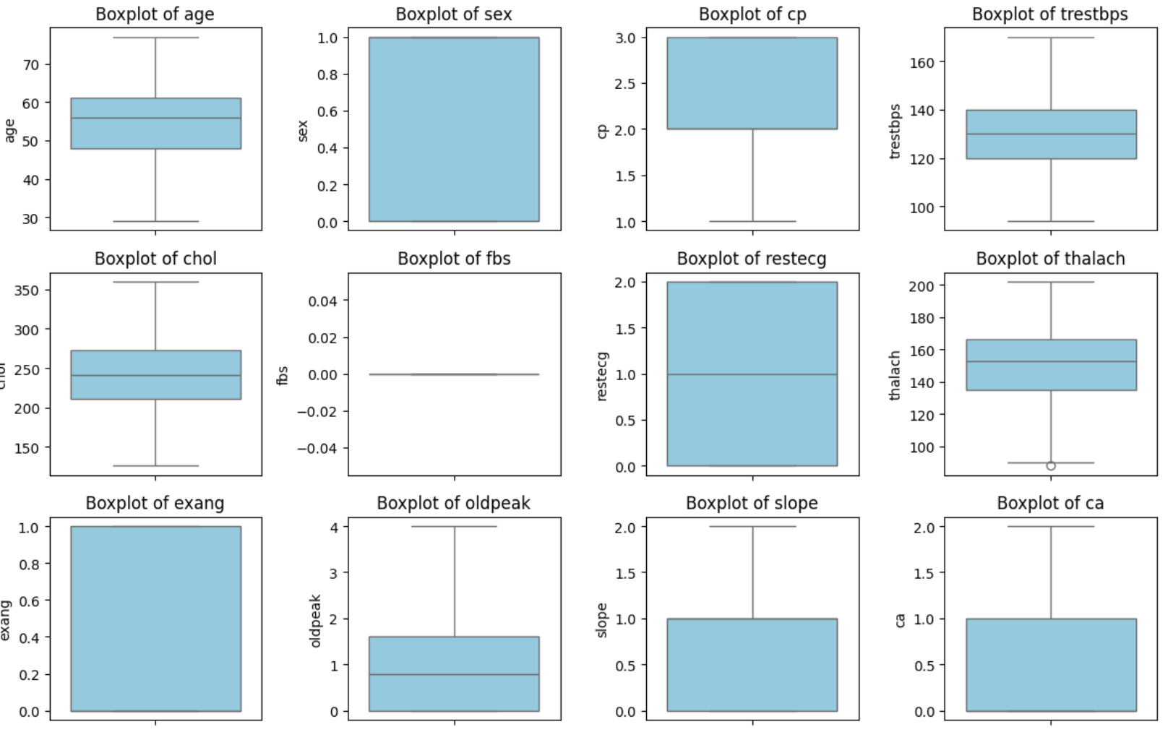
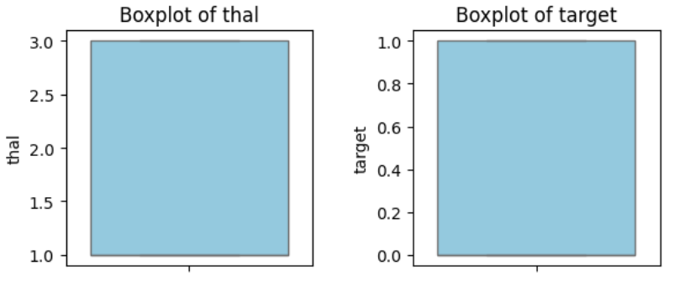
- Feature Correlation Analysis –
- The df.corr() function generates the correlation matrix by calculating numerical feature Pearson correlation coefficient values. This coefficient exists between -1 and 1.
- A heatmap is created using sns.heatmap(), which provides a clear visualization of the relationships between different features.
- We can then fine-tune this dataset by looking into feature correlation: remove redundant features and select the most influtential ones to represent, improving the working efficiency and accuracy of the machine learning model.
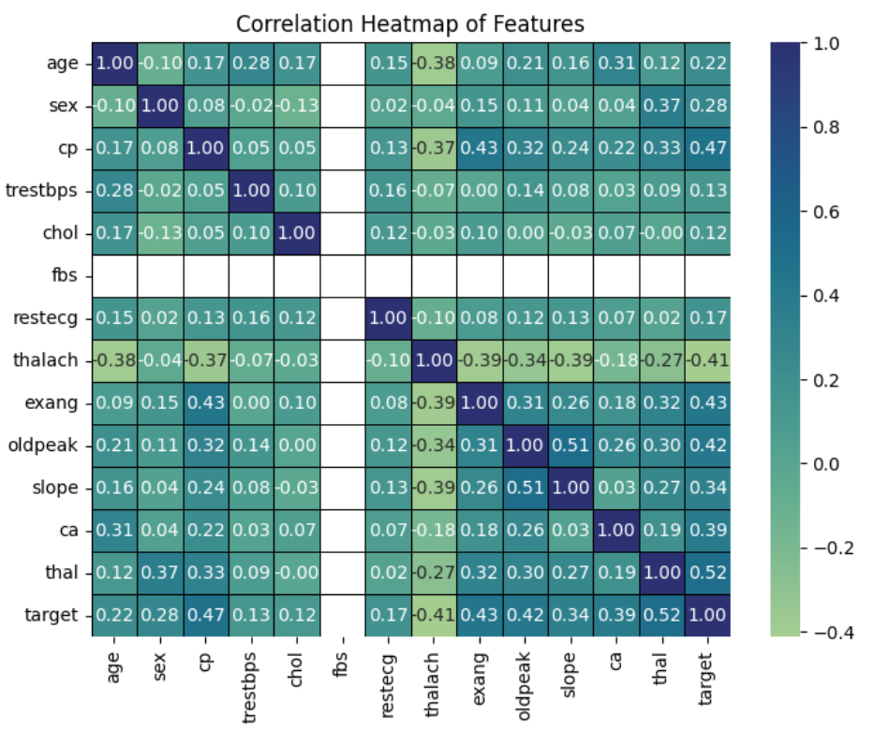

CHAPTER TWO: MODEL SELECTION AND TRAINING

The chapter discusses selection steps for machine learning models that perform heart disease prediction. The chosen models met requirements for binary classification work alongside easy interpretation in addition to effective medical data processing.

- Logistic Regression –
Logistic Regression serves as a popular statistical tool for performing binary classification through methods that determine heart disease presence or absence. Logistic Regression functions well on datasets consisting of features that display linear relationships due to its simple and interpretable design.

- Decision Tree Classifier-
Pertinent heart disease factors are uncovered through Decision Trees while their predictive capabilities are derived from sequential conditions. The model proves valuable for detection of significant elements which lead to heart disease developments.

- Random Forest Classifier-
Random Forest is an ensemble learning method that uses many decision trees to reduce the error rate and overfitting. It is very efficient in medical diagnosis tasks because of the complexity of the feature interactions.

- Gradient Boosting Classifier-
Gradient Boosting serves as an ensemble learning technique which constructs models one after the other to fix errors made in preceding runs. The algorithm proves best when processing organized medical datasets because it enables vital accuracy enhancements.

- Support Vector Classifier (SVC)-
The dataset can achieve optimal decision boundaries using SVC when its patterns exhibit complex relationships which cannot be divided linearly. SVC achieves optimal decision boundaries through the implementation of kernel functions.

CHAPTER THREE: MODEL EVALUATION AND PERFORMANCE ANALYSIS

The selected models get evaluated in this chapter regrading their performance and capability to forecast heart disease development. The evaluation of selected models examined their performance through accuracy, precision, recall and F1-score and AUC-ROC values.
- Model Performance Comparison
Classifier | Accuracy | Precision | Recall | F1-score | AUC-ROC
Logistic Regression | 0.8361 | 0.8214 | 0.8214 | 0.8214 | 0.942
Decision Tree | 0.6885 | 0.6800 | 0.6071 | 0.6415 | 0.6824
Random Forest | 0.8852 | 0.8387 | 0.9286 | 0.8814 | 0.9513
Gradient Boosting | 0.8852 | 0.2327 | 0.9286 | 0.8814 | 0.9513
Support Vector Machine | 0.8361 | 0.8462 | 0.7857 | 0.8148 | 0.9372

- Best Performing Model-
The Random Forest Classifier and Gradient Boosting Classifier demonstrated 88.52% accuracy which they sustained with the optimal precision, recall and F1-score combination. Gradient Boosting demonstrated the highest AUC-ROC score of 0.9513 because of its impressive capability for heart disease distinction from non-heart disease instances.

- Model Analysis-
- The model execution for Logistic Regression resulted in an 83.61% accuracy rate thus confirming its capacity to establish effective linear connections between features and heart disease elements.
- Decision Tree Classifier demonstrated the lowest accuracy rate of 68.85% because it oversimplified training data.
- The Random Forest algorithm defeated decision tree system errors because it combined several models to generate better predictive accuracy reaching 88.52% performance.
- Gradient Boosting showed equivalent performance to Random Forest although its AUC-ROC score was just slightly higher thus becoming the overall top model for binary classification.
- Support Vector Machine (SVC) demonstrated a comparable accuracy of 83.61% compared to ensemble methods yet did not surpass their performance.

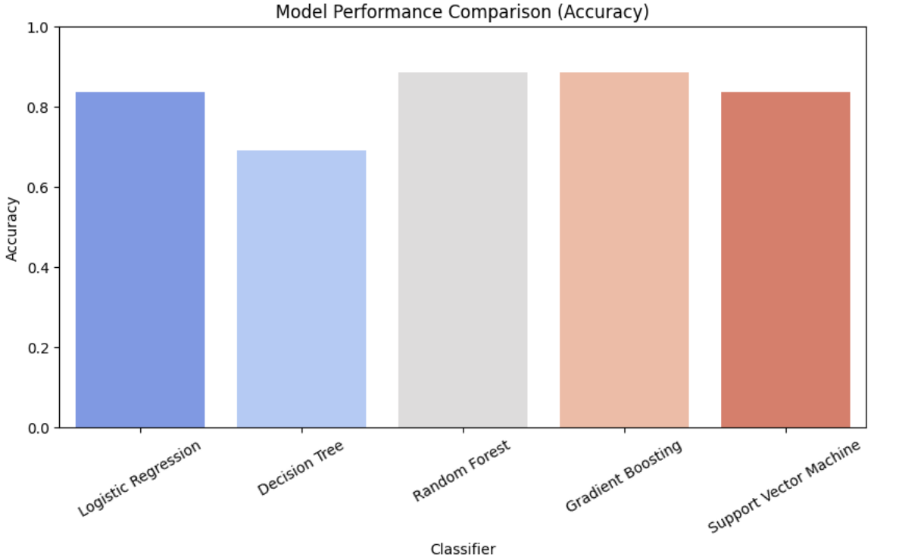
- ROC-
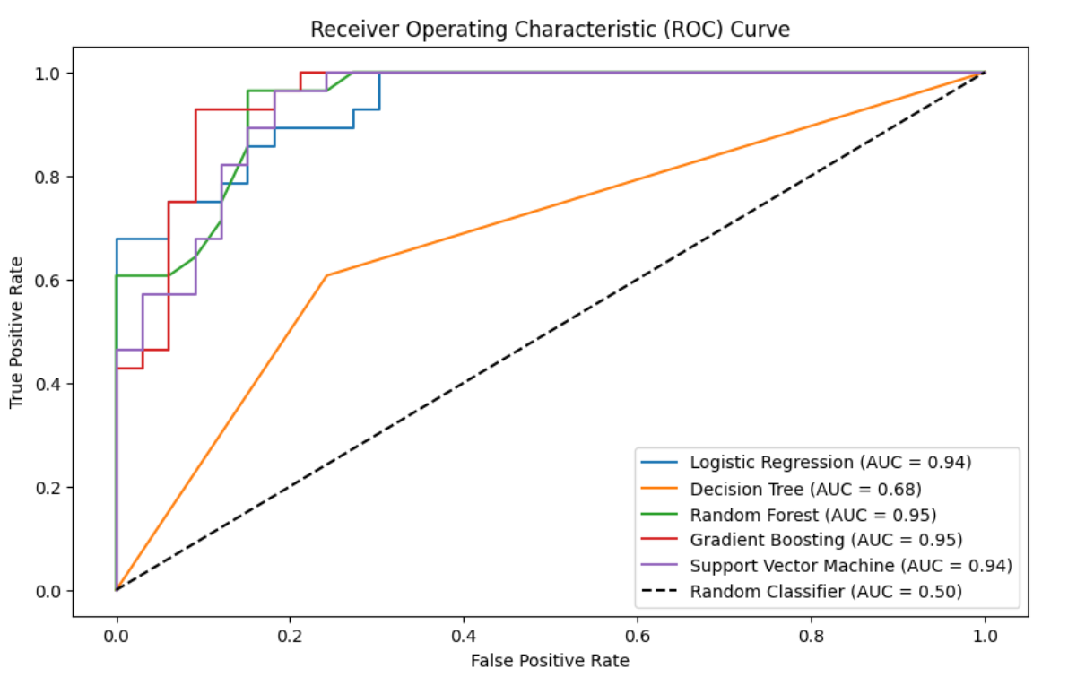
A classifier’s distinction capability between classes becomes visible through the ROC curve representation.
- Random chance predictions draw a diagonal line in the ROC chart while resulting in an AUC value of 0.50
- The Area Under the Curve (AUC-ROC) calculated the entire discriminatory power of the model to separate positive cases from negative cases.
- Gradient Boosting and Random Forest (AUC = 0.95) – These models perform the best, as their curves are closest to the top-left corner.
- Logistic Regression and Support Vector Machine (AUC = 0.94) – These models also perform well but slightly lower than Gradient Boosting and Random Forest.

- Confusion Matrices –
- Logistic Regression-
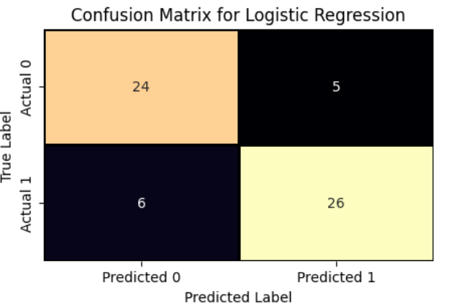
Logistic Regression Analysis achieved a correct classification of 24 true positives together with 26 true negatives within its confusion matrix. The model produced six wrong negative results and five wrong positive outcomes.
- Decision Tree-
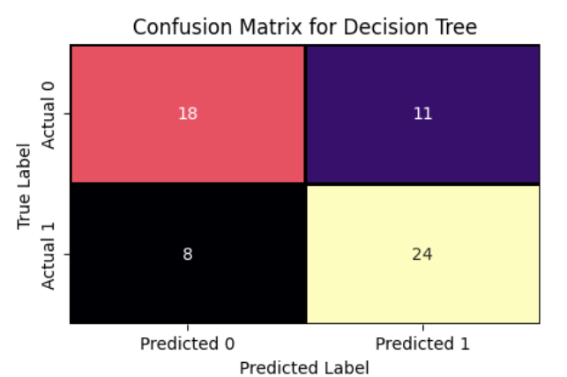
The Decision Tree model achieves comparable results comprising 18 true positives with 24 true negative and 8 false negatives but also 11 false positives.

- Random Forest-
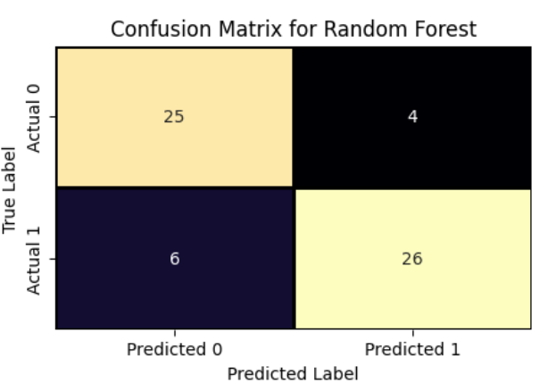
The Random Forest model produces the most effective performance from all presented models . The Random Forest model achieved an accurate performance by returning 25 correct positive hits together with 26 exact negatives yet produced 6 false negative and 4 false positive outcomes.
- Gradient Boosting-
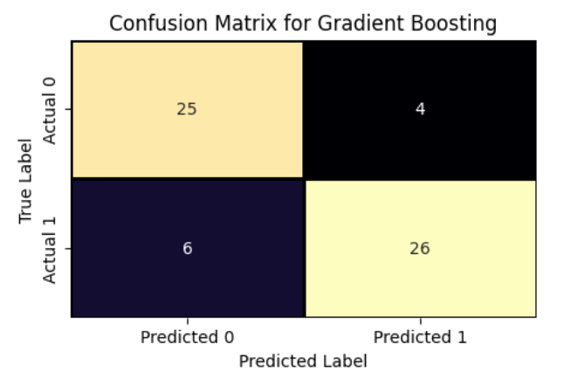
The Gradient Boosting model performed with 25 true negative and 26 true positive classifications and 6 false negative and 4 false positive outcomes in the confusion matrix
- Support Vector Machine (SVM)-
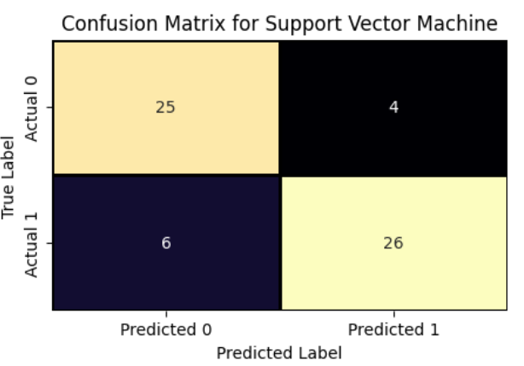
The SVM model achieves a performance level with 25 true positives and 26 true negatives and 6 false negatives and 4 false positives. The performance level of this model matches that of both Random Forest and Gradient Boosting models.
- Insights and Anomalies in Confusion Matrices-
- The Random Forest model and Gradient Boosting model with SVM model achieve maximum overall accuracy by producing fewer misdiagnoses compared to the logistic Regression and Decision Tree models.
- The Logistic Regression model produces the most false positives whereas predicting the positive class.
- The highest number of false negative predictions made by the Decision Tree model indicates it may be positively sensitive to negative class instances.
- All the models exhibit a relatively balanced performance, with no significant discrepancies between the true positive and true negative rates.

CHAPTER FOUR: AIRTIFICIAL INTELLIGENCE IN HEALTHCARE

- Enhanced Diagnostic Accuracy-
- Medical image analysis through AI models enables disease detection in cancer and cardiovascular and neurological diseases at human expert levels and sometimes surpassing their performance.
- Healthcare professionals experience fewer diagnostic errors because AI helps reduce mistakes related to professional fatigued and cognitive limitations and insufficient experience.
- Increased Efficiency in Healthcare-
- The analysis of big datasets through AI diagnostic tools performs fast processing which brings substantial reductions to the diagnosis timeframe.
- The use of AI makes it possible to forecast hospital patient admissions along with intensive care requirements and staff commitments thus enhancing organizational management.
- Enhanced Accessibility to Healthcare Services-
- The analysis capability of AI mobile health applications enables them to provide recommendations to patients who have limited medical services nearby.
- Through AI-driven diagnostic screening technologies healthcare providers will achieve economic opportunities to enhance medical assessments for broader patient access.

CONCLUSION

We developed an AI model with machine learning classifiers for heat disease prediction which we evaluated through performance assessment and key metric measure.
- Data Preprocessing and Features-
- The dataset was cleaned, missing values handled and outliers were imputed using the median.
- Standardization was applied to numerical features for better model performance.
- Model Selection and Evaluation-
- Five classifiers were tested: Logistic Regression, Decision Tree, Random Forest, Gradient Boosting and Support Vector Machine (SVM).
- Models were trained on a standardized dataset using an 80-20 train-test split.
- Performance Metrics-
- The models were evaluated using accuracy, precision, recall, F1-score and AUC-ROC score.
- The best performing model was determined based on accuracy and AUC-ROC score.

- Findings-
- Random Forest and Gradient Boosting emerged as the top performing models, showing a good balance between accuracy and generalization.
- Logistic Regression and SVM performed well but were slightly outperformed by ensemble models.
- Decision Tree showed lower accuracy possibly due to overfitting.

Heart disease prediction using AI methods reached effective results but ensemble methods like Random Forest and Gradient Boosting demonstrated the most reliability for this task. The development of improved models requires further research on deep learning approaches and AI explainability with hyperparameter optimization for better real world model adoption.

Colab Link - https://colab.research.google.com/drive/1qhyqY9wTOxTGZdEhqkMMtULFPfBckm7I?usp=sharing

BIBLIOGRAPHY

Journal Articles:
- Patel, N., Patel, S., et al. (2024) ‘Artificial Intelligence in Healthcare: Perception and Reality’, Journal of Medical Systems. Available at: https://pmc.ncbi.nlm.nih.gov/articles/PMC10587915/.
- Johnson, A., Torres Soto, B., et al. (2020) ‘Artificial Intelligence, Machine Learning, and Cardiovascular Disease’, Journal of the American College of Cardiology. Available at: https://pmc.ncbi.nlm.nih.gov/articles/PMC7485162/.
- Khan, M. A., Alhaisoni, M., et al. (2024) ‘Artificial Intelligence Framework for Heart Disease Classification from Heart Sound Signals’, Scientific Reports. Available at: https://www.nature.com/articles/s41598-024-53778-7.
- Smith, M., Jones, L., et al. (2023) ‘Artificial Intelligence in Diagnosing Medical Conditions and Impact on Healthcare’, Medical Group Management Association. Available at: https://www.mgma.com/articles/artificial-intelligence-in-diagnosing-medical-conditions-and-impact-on-healthcare.
- Gangadhar, R., Kumar, S. S., et al. (2022) ‘Heart Disease Detection Using Machine Learning Methods’, Journal of Medical Artificial Intelligence. Available at: https://jmai.amegroups.org/article/view/9054/html.
Online Repositories and Toolkits:
- g-shreekant (2021) Heart Disease Prediction using Machine Learning. Available at: https://github.com/g-shreekant/Heart-Disease-Prediction-using-Machine-Learning.
- Sun Lab UIUC (2020) PyHealth: A Deep Learning Python Toolkit for Healthcare. Available at: https://github.com/sunlabuiuc/PyHealth.
- Loh, J. (2022) Heart Disease Prediction with Machine Learning. Available at: https://www.kaggle.com/code/janeloh/heart-disease-prediction-with-machine-learning.
- Dwivedi, S. (2023) Heart Disease Prediction Using Machine Learning. Available at: https://www.kaggle.com/code/shivanshdwivedi/heart-disease-prediction-using-machine-learning.
- Kumar-laxmi (2021) Heart Disease Prediction System using Machine Learning. Available at: https://github.com/Kumar-laxmi/Heart-Disease-Prediction-System.

